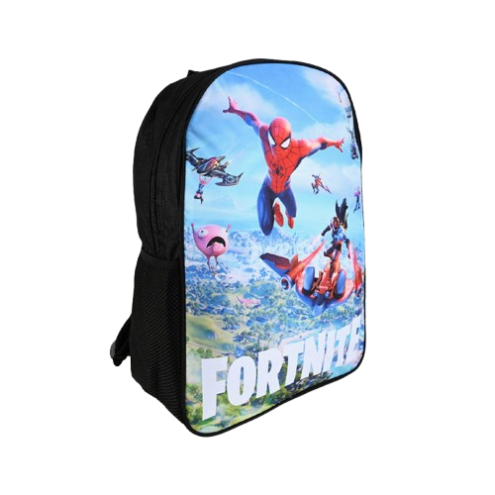

**Product details**

**Fortnite Backpack**

**Price: $34.99**

**Gear Up and Level Up Your Style!**

**The Fortnite Backpack is designed for gamers who want to carry their essentials in style. Featuring bold, iconic designs from the Fortnite universe, it’s perfect for school, gaming events, or casual outings. With spacious compartments and durable construction, this backpack keeps your gear secure while showcasing your love for the game.**

**.**

.

**THANK YOU!**

**WELLCOME TO OUR WEBSITE**